Table of Contents
1. Project Rationale.......................................................................1
2. Problem Analysis and Computational Thinking.............................2
3. Proposed Solution and Functional Requirements..........................3
4. Algorithm Design.......................................................................4
5. Pseudocode..............................................................................5
6. Flowcharts................................................................................6
7. Functional Modules and Logical Design.......................................7
8. Expected Outputs and Test Scenarios.........................................8
9. SDG, Open Source and Digital Public Goods................................9
10. Community Impact and Sustainability.......................................10
11. GitHub and Version Control Evidence.......................................11
12. References............................................................................12

1. Project Rationale

1. Background and problem description
In some communities in Sierra Leone, learners face interruptions in education because of limited connectivity, uneven access to learning materials, and difficulties locating affordable support. A learner may need past questions or a basic lesson but lack reliable internet access or information about available community learning centers. These conditions can make independent study less consistent.

2. Community impact
The problem affects secondary school pupils, adult learners, parents, teachers, and community volunteers. Students can miss revision opportunities, teachers may repeatedly distribute the same materials manually, and community organizations may struggle to communicate learning schedules.

3. Proposed solution
EduReach SL is a proposed low-bandwidth learning support system. A learner chooses a subject and topic, receives a locally stored lesson when available, completes a short practice quiz, and sees a result with recommendations. A volunteer administrator can add verified lessons and update community learning-centre information. This is a design proposal, not a claim that a deployed service already exists.

2. Problem Analysis and Computational Thinking

1. Decomposition
Divide the problem into learner registration, lesson discovery, offline access, quiz assessment, progress feedback, and content administration. Each is a manageable function with defined inputs and outputs.

2. Pattern recognition
Learners repeatedly search by subject, request lessons, answer practice questions and need feedback. The same validation and result-calculation steps can be reused across subjects.

3. Abstraction
Represent each lesson with lesson ID, subject, topic, language, content, and availability status. Represent each quiz question with question ID, choices and correct answer. The logical model does not need to store unnecessary personal information.

4. Algorithmic thinking
Use a sequence of clear instructions to validate the request, search lesson records, handle missing content, present a quiz, and calculate a score. Conditions handle missing lessons and invalid answers; loops handle repeated questions and repeated menu choices.

3. Proposed Solution and Functional Requirements
Inputs: selected language, subject, topic, menu choice, learner answers and administrator content records. Processes: validate inputs, search lesson catalogue, load available content, compare answers, count correct answers, calculate percentage and generate recommendations. Outputs: lesson text, missing content notice, quiz score, learning advice, and administrative confirmation.
Functional requirements: (1) display a menu; (2) search lessons by subject and topic; (3) indicate whether a lesson is stored offline; (4) administer a fixed-length quiz; (5) reject invalid answers; (6) calculate and display results; (7) allow authorized administrators to add or update verified content; (8) exit safely. Non-functional goals include simplicity, accessibility, low data use, privacy, and understandable error messages.

4. Algorithm Design

Main algorithm
1. Start the system and load the verified lesson catalogue.
2. Display language options and ask the user to select one.
3. Repeat: display the main menu and read the user choice.
4. If the choice is View Lesson, request subject and topic; search the catalogue; display the lesson if found or a helpful notice otherwise.
5. If the choice is Take Quiz, request a topic, retrieve its questions, ask each question, validate the answer, and count correct responses.
6. Calculate percentage = (correct answers / total questions) × 100 when total questions is greater than zero.
7. Display score and a recommendation based on the percentage.
8. If the choice is Exit, end the loop; otherwise handle invalid menu choices with an error notice.
9. Stop the system.

4.2 Decision rules
Condition | Action
Lesson exists and is available | Display content
Lesson missing | Show “Lesson unavailable” and suggest another topic
Answer not A, B, C or D | Request the answer again
Score ≥ 70% | Recommend the next topic
Score < 70% | Recommend revising the lesson
Quiz contains zero questions | Show “Quiz unavailable”; avoid division by zero

5. Pseudocode

1. Main menu and lesson search
BEGIN
LOAD verifiedLessons
SET running = TRUE
WHILE running = TRUE DO
DISPLAY "1. View Lesson 2. Take Quiz 3. Exit"
INPUT choice
IF choice = 1 THEN
INPUT subject, topic
CALL FindLesson(subject, topic)
ELSE IF choice = 2 THEN
INPUT topic
CALL TakeQuiz(topic)
ELSE IF choice = 3 THEN
SET running = FALSE
ELSE
DISPLAY "Invalid menu choice"
END IF
END WHILE
END

2. Lesson module
FUNCTION FindLesson(subject, topic)
SET found = FALSE
FOR EACH lesson IN verifiedLessons DO
IF lesson.subject = subject AND lesson.topic = topic THEN
DISPLAY lesson.content
SET found = TRUE
BREAK
END IF
END FOR
IF found = FALSE THEN DISPLAY "Lesson unavailable" END IF
END FUNCTION

3. Quiz and scoring module
FUNCTION TakeQuiz(topic)
SET questions = GetQuestions(topic)
SET total = COUNT(questions)
IF total = 0 THEN DISPLAY "Quiz unavailable"; RETURN END IF
SET correct = 0
FOR EACH question IN questions DO
DISPLAY question.text AND question.options
REPEAT INPUT answer UNTIL answer IN {A,B,C,D}
IF answer = question.correctAnswer THEN
SET correct = correct + 1
END IF
END FOR
SET percentage = (correct / total) * 100
DISPLAY correct, total, percentage
IF percentage >= 70 THEN
DISPLAY "Good progress: continue to next topic"
ELSE
DISPLAY "Revise this lesson and try again"
END IF
END FUNCTION

6. Flowcharts
The diagrams below are flowcharts of the proposed logic. Arrows show the sequence; decision diamonds indicate alternative branches and loopbacks.
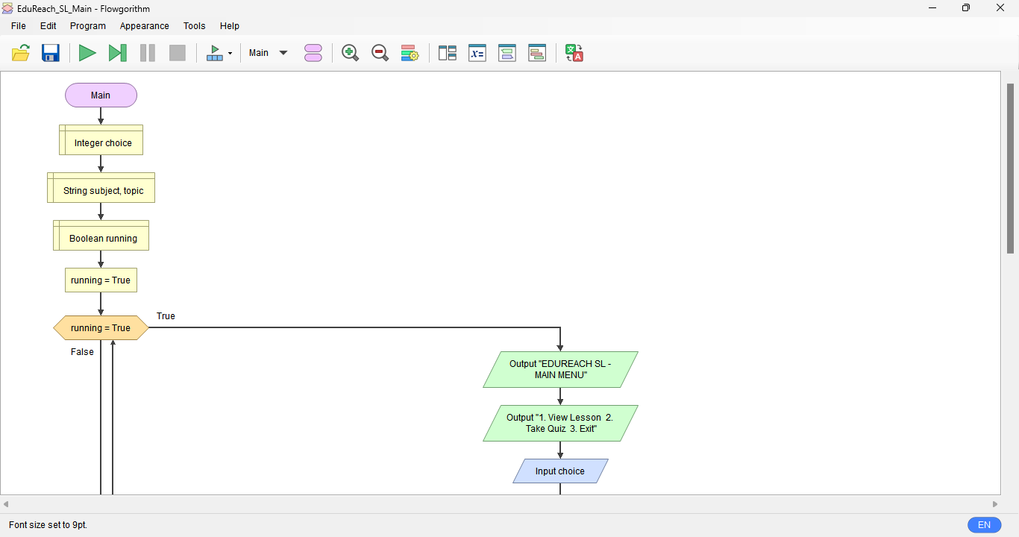
Figure 1. Main menu decision-flow overview (simplified; after each task the menu repeats).
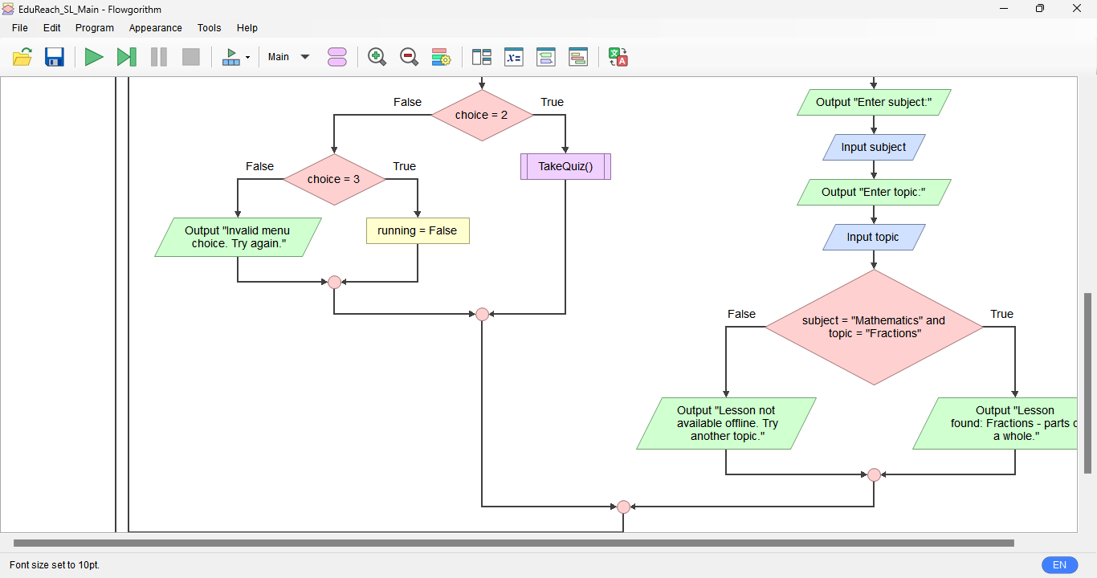
Figure 2. Quiz process overview (the question loop repeats until all questions are completed).

7. Functional Modules and Logical Design
Module / function | Input | Output
DisplayMenu | None | Selected menu choice
FindLesson | Subject, topic | Lesson or unavailable message
GetQuestions | Topic | List of questions
TakeQuiz | Topic and answers | Correct count and score
GiveFeedback | Score percentage | Study recommendation
ManageContent | Admin authorisation and lesson | Updated verified catalogue

1. Variables, constants and data types
Identifier | Type | Purpose
choice | Integer | Menu selection
subject, topic | String | Lesson lookup
running, found | Boolean | Loop and search flags
correct, total | Integer | Quiz counters
percentage | Real / float | Quiz result
PASS_THRESHOLD = 70 | Constant integer | Feedback boundary
questions | List of records | Question collection

2. Logic explanation
Sequence: load records, show menu, read input, perform a selected task. Selection: IF / ELSE IF checks menu choices, lesson availability and feedback threshold. Repetition: WHILE keeps the menu active, FOR EACH scans records and questions, and REPEAT UNTIL validates each answer. Boolean flags track whether a matching lesson was found. Functions separate tasks and support reuse, testing and maintenance.
8. Expected Outputs and Test Scenarios
Scenario | Sample input | Expected output
Lesson available | Mathematics / Fractions | Fractions lesson is displayed
Lesson not available | Science / Astronomy | Lesson unavailable; choose another topic
Successful quiz | 4 correct of 5 | 80%; continue to next topic
Quiz needs revision | 2 correct of 5 | 40%; revise lesson and retry
Invalid answer | E | Ask again for A, B, C or D
Empty quiz | Topic with 0 questions | Quiz unavailable; no division by zero
Exit | Menu choice 3 | Application ends
These are illustrative expected outputs from the logical design, not screenshots of a running application.

9. SDG, Open Source and Digital Public Goods

1. Sustainable Development Goal
The project primarily supports SDG 4: Quality Education, because it aims to improve access to learning resources and self-assessment for underserved learners. It also supports inclusive access by proposing downloadable lessons and simple interfaces.

2. Open-source justification
Publishing the design and future implementation under an appropriate open-source licence would allow local developers and educators to inspect, adapt and translate the system. Benefits include transparency, peer review, reduced duplication and community contribution. Risks such as inaccurate content and privacy exposure require review procedures and secure design.

3. Digital Public Goods potential
EduReach SL could be developed toward Digital Public Goods principles by using open licensing, accessible formats, privacy-conscious data handling, documented standards and an SDG-aligned purpose. A proposal alone is not certified as a Digital Public Good; future developers would need to assess it against applicable requirements.

10. Community Impact and Sustainability
Potential beneficiaries include pupils in low-connectivity areas, teachers, community learning centers and volunteers. Expected benefits are easier revision, consistent access to verified material, and clear learning feedback. To sustain the project, a local education partner could review content each term, volunteers could maintain translations, and the design could prioritise inexpensive hosting and offline distribution. Success could be measured by number of verified lessons, repeat usage, quiz completion and learner feedback, while avoiding collection of unnecessary personal data.

11. GitHub and Version Control Evidence
Required repository name: PROG101_Assignment1_AmaduSajorBarrie_905006116. Create a GitHub account if needed, create this repository, and upload the report, flowchart images, pseudocode file and README.md. Commit work in meaningful stages rather than creating a misleading history.
Suggested genuine commit sequence: “Add problem analysis and rationale”; “Add pseudocode and algorithms”; “Add flowchart diagrams”; “Complete report and README”. Only use these messages when you actually perform the corresponding commits.

Evidence checklist
GitHub repository URL: __________________________________________
[INSERT SCREENSHOT: GitHub repository overview]
[INSERT SCREENSHOT: Git commit history]
[INSERT SCREENSHOT: README.md and uploaded files]

Conclusion
In conclusion, EduReach SL is a proposed learning support system designed to make education easier and more accessible for learners in Sierra Leone. It will help students access learning materials, practise with quizzes, check their results and improve their understanding of different subjects. The project also supports SDG 4, which focuses on Quality Education. If properly developed and maintained, EduReach SL can help reduce learning difficulties, support teachers and provide more educational opportunities for communities with limited internet access.
Overall, EduReach SL aims to make learning simple, accessible and available to everyone.

References
United Nations. (n.d.). Goal 4: Ensure inclusive and equitable quality education and promote lifelong learning opportunities for all. https://sdgs.un.org/goals/goal4
Digital Public Goods Alliance. (n.d.). Digital Public Goods Standard. https://digitalpublicgoods.net/standard/
Open-Source Initiative. (n.d.). The Open-Source Definition. https://opensource.org/osd
GitHub Docs. (n.d.). About repositories. https://docs.github.com/en/repositories
Limkokwing University of Creative Technology, Sierra Leone. (2026). PROG101: Designing Logical Solutions for Sierra Leone Community Challenges [Assignment brief].

